A Minnie Mouse Jumper Gift For My Bff's First Daughter

Finding gifts for someone can be hard, especially when the receiver is your BFF. Isn't it? You can't just pick any teddy bear from the gift store for their kids and expect loads of appreciation. So I brainstormed a lot and finally found a Minnie Mouse Jumper Gift for my BFF's first daughter.

Before I tell you her reaction, let me tell you why I chose it.

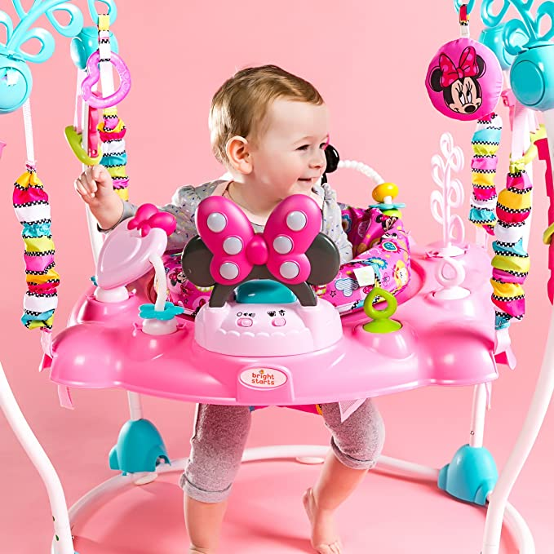

<H1>Joyful Jumper for the Little Ones</H1>

Yes, I'm going to term it the best gift for kids as it took me a lot of thinking before deciding what to buy for my best friend's daughter.

Jokes aside, the Jumper is amazing for kids with so many exciting features. I was so amused that I felt sad for not having it during my childhood. And I'm not kidding this time; I felt so.LOL!

The Minnie Mouse Jumper is like a best friend for your little ones; it won't refuse to play whenever they want and provide unrestricted fun to kids with multiple playing elements.

<H2>There’s a Lot to Love About it</H2>

- Music and Lights

It is a battery-powered Jumper with inbuilt music and lights that activate whenever the baby jumps. The magical sound is melodious to kids' ears and makes them laugh in excitement.

- 360-degree rotating seat

It doesn't keep the kids intact to only one position. The super-comfortable seat can rotate in every direction(360 degrees), offering more freedom to kids to play.

- Equipped with 12 Toys and Extra Toy Loops

The lights and music are not the only fun components for kids. It has 12 toys attached with extra toy loops that keep the kids engaged.

- Easy to Clean

The well-cushioned seat of the Jumper supports machine wash and thus can be cleaned easily.

<H2>The Ultimate Source of Happiness for Kids</H2>

It is a great gift for the little ones, and the exciting features of it bring in maximum fun for kids of 6 months and above.

What was my friend's reaction?

The moment my friend opened it up, she went through a series of surprises with every unique feature she discovered over a few minutes. The moment was so priceless for me.

Well, putting my bare thoughts, obviously I won't mind receiving any kind of gift from my friends, but I would definitely love it if someone would put some extra effort into finding the same. And I think that's the case with almost everyone.

I hope this article saved you from a lot of hardwood in finding the best gift for kids.

